Role Details

Job Title: | Depute Social Care Manager (Night Shift) | Reports to: | Social Care Manager (Night Shift)
Grade & Salary Range: | £39,014.10 - £41,750.80 – dependent on experience and qualifications
Work Location: | Stepdown Community Services – All sites

Role Purpose

The Depute Social Care Manager (Night Shift) will assist the Social Care Manager and deputise as required in relation to the provision of management support and direction to staff for young people moving in to, resident in and moving on from placements in Stepdown Houses.

The Depute Social Care Manager (Night Shift) will have ‘hands on’ responsibilities including a senior practitioner/exemplar role to ensure that young people are safe, healthy, active, nurtured achieving, respected, responsible and included in line with GIRFEC.

As directed by the Social Care Manager (Night Shift), the Depute Social Care Manager (Night Shift) will ensure that work with young people and their families are consistent with legislative, regulatory, organisational and procedural requirements and bench-marks positively against current good practice standards and guidance.

Under the direction of the Social Care Manager (Night Shift), the Depute Social Care Manager (Night Shift) will provide supervision, direction and support to staff to deliver on agreed Care Plans and objectives to achieve best outcomes for young people and ensure that appropriate opportunities are made available to staff to enable them to maximise performance.

Role Accountabilities & Key Activities

- To ensure that the highest possible standards and quality of care are provided to our young people.
- To ensure that, in partnership with other key agencies, the best possible outcomes are achieved by young people.
- To effectively support the development, maintenance and monitoring of systems and structures which reflect values and ethics inherent in the Code of Practice for Employers and Code of Conduct for Staff as published by the Scottish Social Services Council.
- To effectively manage and account for the use of financial and other resources.
- To manage the performance of staff so that Care Plans are effective and objectives achieved.
- To contribute to the selection and recruitment of staff to meet service requirements.
- To assist the Social Care Manager (Night Shift) with the preparation of staff rotas to ensure that staffing levels in the cottages are appropriate to meet the needs of the young people and meet regulatory requirements.
- To be an active member of the management team and to participate in the out-of-hours management of the Houses.
- To promote the development of both individual members of staff and the staff team to maximise performance and deliver best outcomes for young people.
- To effectively support and contribute to the management of continuous quality improvement which reflects current best practice and ensure compliance with National Care Standards, Care Inspectorate advice, guidance and recommendations.
- To ensure that the care environment effectively meets the physical, social, emotional and developmental needs of young people.
- To promote the development, maintenance and monitoring of a safe working environment.
- To promote equal Opportunities and anti-discriminatory practice.
- To carry out such other duties as may be required by the exigencies of the service.

Key Relationships
- As Depute Social Care Manager (Night Shift) the role has accountability to the smooth running of Stepdown Community Services and your assigned house.
- The role will work with Service Managers, Social Care Managers, Depute Social Care Managers, Social Care Workers and the Senior Management Team to share best practice.
- On a day to day basis, the Depute Social Care Manager (Night Shift) will be required to use initiative to progress and support day to day running of their House with more complex issues being referred to the Service Manager, when required.
- The Depute Social Care Manager (Night Shift) role interacts with children and young people, all colleagues within Stepdown Community Services, Social Work departments of Local authorities, parents, third sector professionals, Children’s Reporter, Police Scotland
- Given the nature of the role, key relationships will include frequent contact with Head of Service, Service Managers, HR Manager, Learning and Development, and other members of staff, children and young people, parents and external visitors to Stepdown Community Service
- External Government Bodies such as Scottish Social Services Council, Local Authorities, Scottish Government Child Placement Team, Procurator Fiscal

Key Relationships

- Provide leadership and direction to the team to meet business and individual objectives
- Promote an inclusive culture, embracing diversity and ensuring all team members are treated equally and fairly.
- Act as a role model, inspire others, and project Stepdown values in all that you do.
- Communicate effectively to ensure team members are on board and are well informed.
- Conduct supervision (formally and informally) and annual Personal Development Plan’s (PDP) to monitor and evaluate individual performance, offering constructive feedback and tailored development plans to encourage continuous personal development and growth.
- Provide day to day line management support including holiday approvals, dealing with absences, etc.
- Demonstrate high quality management and deal with sometimes challenging or complex situations, with the support of Human Resources.
- Continuously develop your own leadership and people management skills.

Stepdown Community Services Values

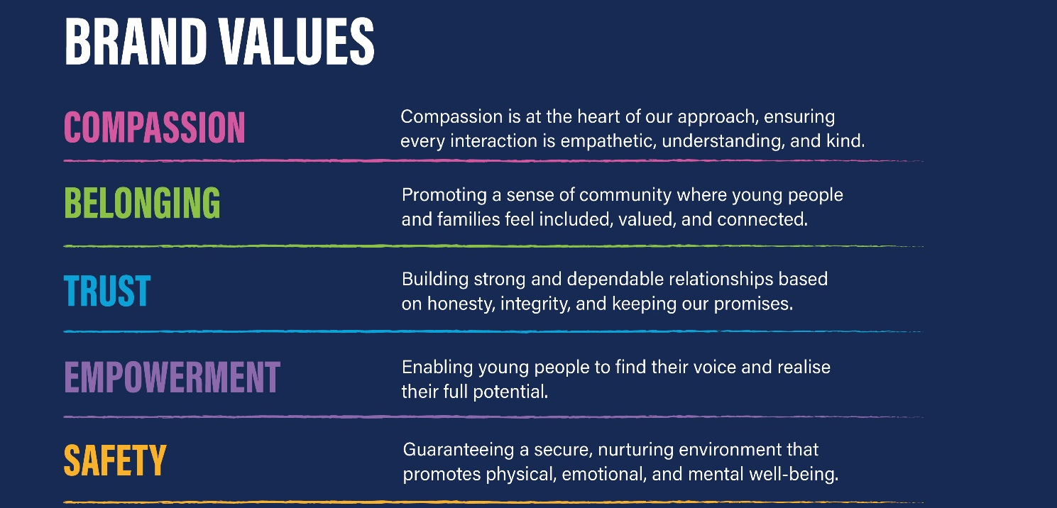

This Role Profile is to provide a clear and concise statement of the main tasks and activities of the post; it is not intended to be an exhaustive list of every aspect of the post holder’s duties. Stepdown reserves the right to change or modify your job description as and when required

Context

Location: | In line with the contractual terms for Stepdown Community Services  - All Stepdown sites
Terms & Conditions Applicable to the Role: | General | x
Terms & Conditions Applicable to the Role: | SNCT
Terms & Conditions Applicable to the Role: | Other
Role Status: | Permanent | x
Role Status: | Temporary
Role Status: | Sessional
Working Hours:  (per week) | 35 hours
Working Hours:  (per week) | 37 hours | x
Working Hours:  (per week) | Other (please specify)
Work Pattern: |  | Mon | Tues | Wed | Thurs | Fri | Sat | Sun
Work Pattern: | Start Time
Work Pattern: | Finish Time
Work Pattern: | Unpaid Break
Work Pattern: | Total Daily Hours
Shift Pattern: |  | Mon | Tues | Wed | Thurs | Fri | Sat | Sun
Shift Pattern: | Days to be worked
Shift Pattern: | No of hours to be worked per day
Shift Pattern: | Over how many weeks
Shift Pattern: | Other relevant information: | 5 days over 7 days including weekends and public holidays – flexibility required
Requirement to work out with normal work/shift pattern: | Yes | x
Requirement to work out with normal work/shift pattern: | If ‘yes’ please give details | Working additional/amended hours when required depending on the needs of the service
Requirement to work out with normal work/shift pattern: | No
On Call | Yes | On call responsibilities
On Call | If Yes, describe frequency | Whilst on shift and when required
On Call | No
Disclosure: | Not Applicable
Disclosure: | Standard
Disclosure: | PVG | x
Disclosure: | Other (please specify)

Personal Specification

Personal Specification | Essential (must have) | Desirable (would like to have)
KNOWLEDGE | - Sound Knowledge of the role and accountability of the role  - Demonstrates a knowledge and understanding of policies and procedures required within a secure unit  - Knowledge and understanding of the Code of Practice for Employers and Employees as published by the SSSC  - Knowledge and experience of developing and managing strategies to advance the skills and competence of staff
SKILLS | - Team working  - Good interpersonal and motivational skills  - Time management  - Planning and organisational skills  - Written and verbal communication skills  - Tact, patience and understanding  - Mental strength to cope with challenging situations  - Ability to keep accurate records and write reports
EXPERIENCE  (Occupational – Minimum Experience) | - Experience of working in social care and with young people  - Experience of managing people | Preferably in residential child care or secure care
EDUCATION/  TRAINING  (Educational – Minimum Qualifications) | - SVQ4 (or working towards this)  - HNC  - SSSC Registered or suitable to apply for registration
PROFESSIONAL QUALITIES | - Capabilities in relation to reviewing the safety and welfare of children and young people  - Give support and commitment to the work of the team, making effective efforts to develop skills and competences of yourself and others  - Appreciate the significance of safe care and interpreting this accurately for individual service users and others  - Recognise own areas of responsibility and accountability  - Maintain high standards of service delivery  - Have a consistency of approach in work practice
PERSONAL QUALITIES | - Works to ensure credibility in effectively managing relationships  - Self-motivated  - Demonstrates and can do approach  - Approachable  - Team Player  - Ability to work on own initiative whilst taking responsibility for your own actions  - Work under pressure and remain calm  - Ability to work with minimum supervision  - Inclusive and respectful  - Carry out role with credibility and professionalism at all time  - Structured approach to planning and organising with an ability to prioritise  - Flexible, adaptable and imaginative in dealing with challenging situations  - An ability to listen and be sympathetic whist responding to concerns, motives and feelings of others  - Be open minded when dealing with situations  - An emotional awareness of self and others  - Assertive and effective in leadership  - Planning and decision making
DRIVING LICENCE | Yes

